Spotlight-7 TEST 5
1.Vocabulary
A. Underline the correct item.
1. I went to the clothes shop yesterday to buy some socks/diaries.
2. The mirror had a big crack in it, so we took it back/away to the shop.
3. Tom bought a beautiful ring for his wife from the homeware/jewellery shop.
4. I saw the coolest glasses at the optician’s/ chemist’s.
5. I need to go to the stationary/electronics shop to buy a battery for my MP3 player.

B. Complete the sentences with the words from the box below. One is extra.
• ambulance • doctor’s • fever • exhausted • stomachache • ankle
6. If you break your leg, you should call for an …………………………….
7. If you have a high ………………., you should put a cold pack on your forehead.
8. Sally, don’t forget your …………………… appointment at 5 pm .
9. What’s up? - Oh, I’ve twisted my …………….
10. I feel so …………………. - You should lie down and get some rest.

2.Grammar

A. Underline the correct quantifier.

1. There are a few/any eggs in the fridge.
2. We haven’t got much/few time.
3. There are much/a lot of skirts to choose from!
4. There is any/some juice in the glass.
5. There isn’t many/any coffee left.

B. Fill in the gaps with the correct words:
• apart • out with • myself • himself • behind •
6. Have you fallen ……………. Mary? She didn't talk to you this morning.
7. Our car is falling ……………. We should replace it soon. - Yes, it’s really old.
8. There's something wrong with David. He's falling …… with his work.
9. I’ve cooked this cake ……
10. My Dad built our house …….

3.Everyday English
Choose the correct response
- Have you been to the doctor yet?  - Are you all right?  - Is something wrong?  - Doctor, how bad is it?  - I am worried about the exams.  - I don’t have time to finish it by myself! | - Everything will be all right. You revised well.  - Yes, I am fine, thank you.  - Let me help you.  - No. Why? Do I look stressed?  - It’s nothing serious.  - Yes. He gave me antibiotics.

4.Reading

Read the e-mail and answer the questions

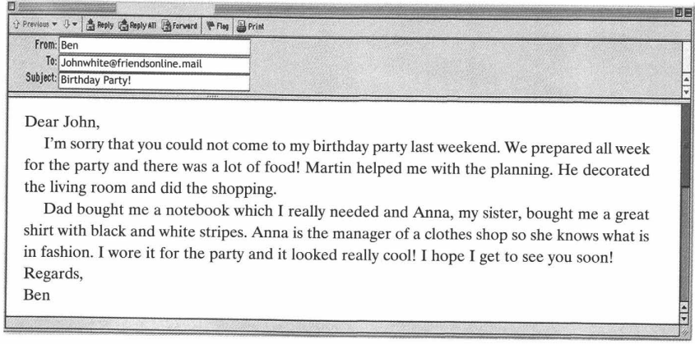

- Who is Ben sending an e-mail to?
- How long did Ben and Martin prepare for the party?
- How did Martin help?
- Which shops did Ben’s parents come from?
- What is Anna’s job?

5.Listening
Listen to an advertisement for a new medicine and fill in the missing information
